Navigation Bar
Top Nav | Dropdown Items
Platform | Platform Overview, Threat Intelligence Dashboard, Workflow, Integrations
Solutions | Digital Risk Protection, Dark Web Intelligence, Brand Protection, Attack Surface Detection, Takedown Services
Use Cases | Credential Leakage, Info-Stealer Logs, Phishing & Typosquatting, Social Media Impersonation, Rogue Apps, Executive Monitoring, External Asset Exposure, Compliance & Reporting
Company | About Cybersee, Why Cybersee, Partners, Customers, Contact

CTA buttons: 1)Request Free Exposure Scan 2) Book a Demo (redirect to https://calendly.com/m-alsalahi-cybersee/30min?month=2026-04)

Navigation Bar Content + Structure

Platform Subpage 1: Platform Overview
Hero section
Headline: One Platform to Detect, Validate, and Respond to External Cyber Threats
Subheadline: Cybersee gives security teams visibility into dark web leaks, brand impersonation, phishing infrastructure, exposed assets, and external attack signals — with workflows to prioritize risk, accelerate takedowns, and support executive reporting.
CTA buttons:
- Book a Demo
- Request Free Exposure Scan

Page sections

1. What Cybersee does
Explain the platform in simple terms.
Cybersee continuously monitors external sources for threats targeting your organization, including leaked credentials, stealer logs, phishing domains, fake social accounts, rogue apps, exposed assets, and threat actor activity.

2. Platform workflow
Show the workflow visually:
Detect → Validate → Prioritize → Alert → Takedown → Report
Each step should have a small explanation:
Step | Description
Detect | Monitor dark web, brand abuse, phishing, rogue apps, and exposed assets.
Validate | Remove noise, enrich findings, and confirm relevance to your organization.
Prioritize | Score threats based on severity, source credibility, asset relevance, and business impact.
Alert | Notify security teams with evidence, context, and recommended next steps.
Takedown | Initiate response workflows for phishing, impersonation, and brand abuse.
Report | Generate executive and operational reports for stakeholders.

3. Core platform modules
Show 4 cards:
- Dark Web Intelligence
- Brand Protection
- Attack Surface Detection
- Automated Takedown Services
Each card should include:
- one-line explanation
- 3 detected threat types
- link to solution page

4. Product screenshots
Show real or anonymized screenshots:
- Threat overview dashboard
- Credential leak detail
- Brand impersonation alert
- Attack surface exposure page
- Takedown case tracker
- Executive report

5. Saudi/GCC platform advantage
Suggested copy:
Cybersee is built and hosted in Saudi Arabia, with focus on Saudi and GCC threat signals, Arabic-language monitoring, local brand abuse patterns, and the operational needs of regional security teams.

6. Final CTA
Headline:
See How Cybersee Fits Into Your Security Workflow
Buttons:
- Book a Demo
- Request Free Exposure Scan

Platform Subpage 2: Threat Intelligence Dashboard

Page purpose
This page proves that Cybersee is a real product with useful workflows, not just a monitoring service.

Hero section
Headline:
A Threat Intelligence Dashboard Built for External Risk Visibility
Subheadline:
View leaked credentials, phishing domains, impersonation attempts, exposed assets, and dark web mentions in one place — with severity, evidence, source context, and recommended actions.
CTA:
- See the Platform in Action

Page sections

1. Dashboard overview
Explain what users see when they log in.
Include:
- active threats
- critical alerts
- affected assets
- detected credentials
- phishing/brand abuse cases
- takedown status
- risk trends

2. Alert detail view
Show what a single alert contains.
Include:
- threat type
- severity
- source
- detection date
- affected domain/email/asset
- evidence
- confidence score if available
- recommended action
- owner/status

3. Filtering and prioritization
Explain how users filter threats.
Include:
- severity
- source
- module
- status
- affected asset
- detection date
- confidence
- business unit if applicable

4. Screenshots to include
Screenshot | Caption
Main dashboard | View all external threats by severity, module, and status.
Alert detail | Review evidence, source, affected asset, and recommended action.
Credential leak view | Track exposed credentials and prioritize remediation.
Takedown tracker | Monitor takedown cases from submission to resolution.

5. Final CTA
Want to See Your Organization’s Exposure?
Buttons:
- Book a Demo
- Request Free Exposure Scan

Platform Subpage 3: Threat Detection Engine

Page purpose
This page explains what Cybersee monitors and why its coverage matters.

Hero section
Headline:
Continuous Detection Across the External Threat Landscape
Subheadline:
Cybersee monitors dark web sources, breach data, phishing infrastructure, impersonation attempts, rogue apps, and exposed assets to identify threats targeting your organization before they escalate.

Page sections

1. Sources monitored
Use grouped source categories:
Source Category | Examples
Dark Web & Deep Web | Forums, marketplaces, breach dumps, ransomware leak sites
Credential Exposure | Stealer logs, exposed emails, leaked passwords, combo lists
Brand Abuse | Lookalike domains, phishing pages, fake login portals
Social & App Impersonation | Fake social accounts, rogue mobile apps, impersonation profiles
Attack Surface | Domains, subdomains, open services, certificates, exposed panels
Regional Signals | Saudi/GCC-focused threat mentions, Arabic-language signals, local brand abuse

2. What Cybersee detects
List:
- leaked employee credentials
- customer data exposure
- executive mentions
- phishing domains
- typosquatting
- fake social media accounts
- rogue mobile apps
- exposed assets
- dark web chatter
- ransomware mentions

3. Why coverage matters
Suggested copy:
External threats are fragmented across forums, marketplaces, phishing infrastructure, social platforms, app stores, and exposed internet-facing assets. Cybersee brings these signals into one platform so security teams can act faster.

4. Visual direction
Use a source coverage map or grid:
Dark Web → Brand Abuse → Attack Surface → Social/App → Regional Signals

5. Final CTA
Find Out What Cybersee Can Detect for Your Organization
Button:
- Request Free Exposure Scan

Platform Subpage 4: Validation & Risk Scoring

Page purpose
This is important because security buyers hate noisy tools. This page explains how Cybersee reduces false positives and prioritizes what matters.

Hero section
Headline:
Reduce Noise and Focus on the Threats That Matter
Subheadline:
Cybersee enriches and prioritizes external threat findings using source context, severity, relevance, recency, asset impact, and customer-specific validation workflows.

Page sections

1. Why validation matters
Suggested copy:
External monitoring tools can generate high volumes of alerts. Without validation and prioritization, security teams waste time chasing low-value findings. Cybersee helps teams focus on relevant, actionable threats.

2. Scoring factors
Use cards:
Scoring Factor | What It Means
Source Credibility | How reliable and relevant the source is
Threat Severity | Potential impact on users, customers, or assets
Asset Relevance | Whether the finding relates to your domains, employees, brand, or infrastructure
Recency | How recent the exposure or activity is
Evidence Quality | Whether the finding includes usable proof
Business Context | Whether the affected asset or identity is high-value

3. Credential validation
Mention carefully:
For enterprise deployments, Cybersee can support credential validation workflows using approved customer context, such as domain ownership, detection date, identity relevance, and password reset timing where integrations are available.
If AD integration is confirmed, say:
Cybersee can integrate with Active Directory or identity systems to help validate whether exposed credentials may still represent active risk.

4. Alert lifecycle
Show:
New → Validated → Prioritized → Assigned → In Progress → Resolved

5. Final CTA
See How Cybersee Prioritizes External Threats
Button:
- Book a Demo

Platform Subpage 5: Takedown & Response Workflow

Page purpose
This page shows that Cybersee is not just “monitoring.” It helps customers act.

Hero section
Headline:
From External Threat Detection to Takedown Action
Subheadline:
Cybersee helps teams manage response workflows for phishing domains, brand impersonation, fake social accounts, rogue apps, and malicious online content.

Page sections

1. What can be actioned
Cards:
- phishing domains
- typosquatting domains
- fake social media accounts
- rogue mobile apps
- impersonation pages
- fake login portals
- brand abuse content

2. Takedown workflow
Visual pipeline:
Detected → Evidence Collected → Case Created → Submitted → Escalated → Resolved → Reported

3. Case management
Explain:
- status tracking
- evidence collection
- owner assignment
- notes
- timestamps
- escalation updates
- closure report

4. SLA / expectations
Be careful here. Do not promise “under 24 hours” unless true.
Suggested copy:
Takedown timelines vary depending on the platform, registrar, hosting provider, and evidence requirements. Cybersee helps structure and accelerate the process through documented workflows, evidence packages, and partner-supported escalation where applicable.

5. Final CTA
Need Support With Brand Abuse or Phishing Takedowns?
Buttons:
- Talk to Cybersee
- Request Brand Exposure Scan

Platform Subpage 6: Reporting & Executive Insights

Page purpose
This page targets CISOs, executives, compliance teams, and risk teams.

Hero section
Headline:
Turn External Threat Data Into Executive-Ready Reports
Subheadline:
Cybersee helps security teams communicate external risk through dashboards, summaries, evidence, trends, and reports built for technical and non-technical stakeholders.

Page sections

1. Report types
Include:
- executive summary
- dark web exposure report
- credential exposure report
- brand protection report
- attack surface exposure report
- takedown status report
- monthly risk trend report

2. What reports include
- key findings
- severity breakdown
- affected assets
- evidence
- recommended actions
- status updates
- trend analysis
- screenshots
- remediation summary

3. Who uses reports
Audience | What They Need
CISO | Risk overview and priorities
SOC Team | Actionable alerts and evidence
Compliance Team | Documentation and reporting
Executives | Business impact and trend summary
Partners | Delivery and client reporting

4. Visual direction
Show report preview cards:
- PDF report mockup
- dashboard charts
- alert summary
- executive summary page

5. Final CTA
Get a Sample Cybersee Threat Report
Button:
- Download Sample Report

Platform Subpage 7: Integrations & API

Page purpose
This page shows deployment readiness and SOC workflow fit.

Hero section
Headline:
Connect External Threat Intelligence to Your Security Workflow
Subheadline:
Cybersee supports alert delivery, case workflows, reporting, and integration options to help security teams operationalize external threat intelligence.

Page sections

1. Integration categories
Category | Examples
Alerting | Email, Slack, Microsoft Teams
Ticketing | Jira, ServiceNow if applicable
SIEM/SOAR | Splunk, Sentinel, QRadar, Cortex XSOAR if applicable
Identity Validation | Active Directory / Entra ID if applicable
API | REST API, webhooks
Reporting | PDF, CSV, executive reports
Only show integrations that are real or planned. If planned, label them clearly.

2. Why integrations matter
Suggested copy:
External threat intelligence is most valuable when it reaches the right team quickly. Cybersee helps route validated alerts into the tools your SOC, incident response, and risk teams already use.

3. API / webhook section
Explain:
- retrieve alerts
- push events
- update case status
- export reports
- automate workflows

4. Security and access
Include:
- role-based access
- audit logs if available
- API keys
- secure authentication
- data privacy

5. Final CTA
Discuss Integration Requirements With Cybersee
Button:
- Talk to Product Team

Hero Section

Badge
Saudi-Hosted Digital Risk Protection Platform

Headline
Detect and Respond to External Cyber Threats Before They Impact Your Business

Subheadline
Cybersee helps security teams monitor leaked credentials, phishing domains, brand impersonation, exposed assets, rogue apps, and dark web threats — with workflows to validate, prioritize, alert, and initiate takedowns.

Live Threat cards
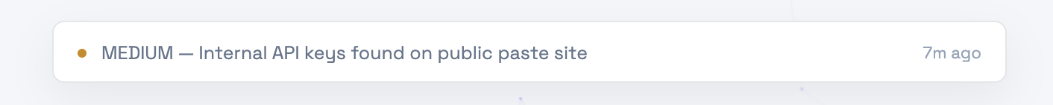

Buttons
Book a Demo
Request Free Exposure Scan

Trust Bar
Trusted By

Add logo for:
- Cognna
- Cyberxi
- UQU
- zid
- marn.io
- Ejabiah
- Trell
- Lite
- Aljeraisy HR
- Flat6labs
- Inspireu

The Problem

Eyebrow: EXTERNAL THREAT EXPOSURE

Heading: External Threats Are Targeting Your Brand, People, Assets, and Data

Subheading: Cyber risks no longer start only inside your network. Attackers operate across dark web forums, leaked credential markets, phishing domains, fake social accounts, rogue apps, and exposed public-facing assets. Without continuous external visibility, security teams may discover threats only after customers, employees, or attackers report them.

Cards

Leaked Credentials
Employee credentials exposed through breach dumps, stealer logs, and dark web marketplaces can lead to account takeover, fraud, and unauthorized access.

Phishing Domains
Lookalike domains and fake login pages can target your customers, employees, and partners before your team even knows they exist.

Brand Impersonation
Fake social accounts, impersonation pages, and fraudulent online profiles can damage trust and expose customers to scams.

Rogue Apps
Fake mobile apps using your brand can mislead users, collect sensitive data, and create reputational risk.

Exposed Assets
Unknown domains, subdomains, open services, expired certificates, and misconfigurations can give attackers an easy starting point.

Dark Web Chatter
Threat actor mentions, marketplace listings, and discussions involving your organization can signal early risk before an incident escalates.

Closing line
The problem isn’t that external threats exist.
The problem is that most teams discover them too late.

CTA
Request Free Exposure Scan
Secondary link:
See how Cybersee detects these threats

The solution

Eyebrow: THE CYBERSEE PLATFORM

Heading: One Platform to Detect, Validate, and Respond to External Threats

Subheading: Cybersee brings external threat signals into one platform, helping security teams monitor dark web exposure, phishing domains, brand impersonation, rogue apps, and exposed assets — then validate findings, prioritize risk, initiate response, and report to stakeholders.

Workflow Cards

Detect
Continuously monitor external sources including dark web forums, breach dumps, stealer logs, phishing domains, social platforms, app stores, and exposed public-facing assets.

Validate
Reduce noise by enriching findings with source context, evidence, relevance, recency, and customer-specific indicators.

Prioritize
Score threats based on severity, affected asset, business impact, confidence, and urgency so teams focus on what matters first.

Alert
Notify the right teams with clear evidence, affected assets, recommended actions, and status tracking.

Takedown
Support structured takedown workflows for phishing domains, fake social accounts, rogue apps, and brand impersonation.

Report
Generate executive and operational reports that show exposure, actions taken, trends, and remaining risk.

Closing Line
From detection to action, Cybersee helps your team move faster against external threats before they become incidents, fraud, or brand damage.

CTA
See the Platform in Action
Secondary CTA:
Book a Demo

Delete The blind spot section+ Live intelligence section

Solution Section

Eyebrow: SOLUTION OVERVIEW

Heading: One Platform to Detect, Validate, and Respond to External Threats

Subheading: Cybersee brings external threat signals into one platform, helping security teams monitor dark web exposure, phishing domains, brand impersonation, rogue apps, and exposed assets — then validate findings, prioritize risk, initiate response, and report to stakeholders.

Then UI visual of our dashboard like this with Product tabs above screenshot
- Brand Protection
- Attack Surface Detection
- Dark Web Intelligence
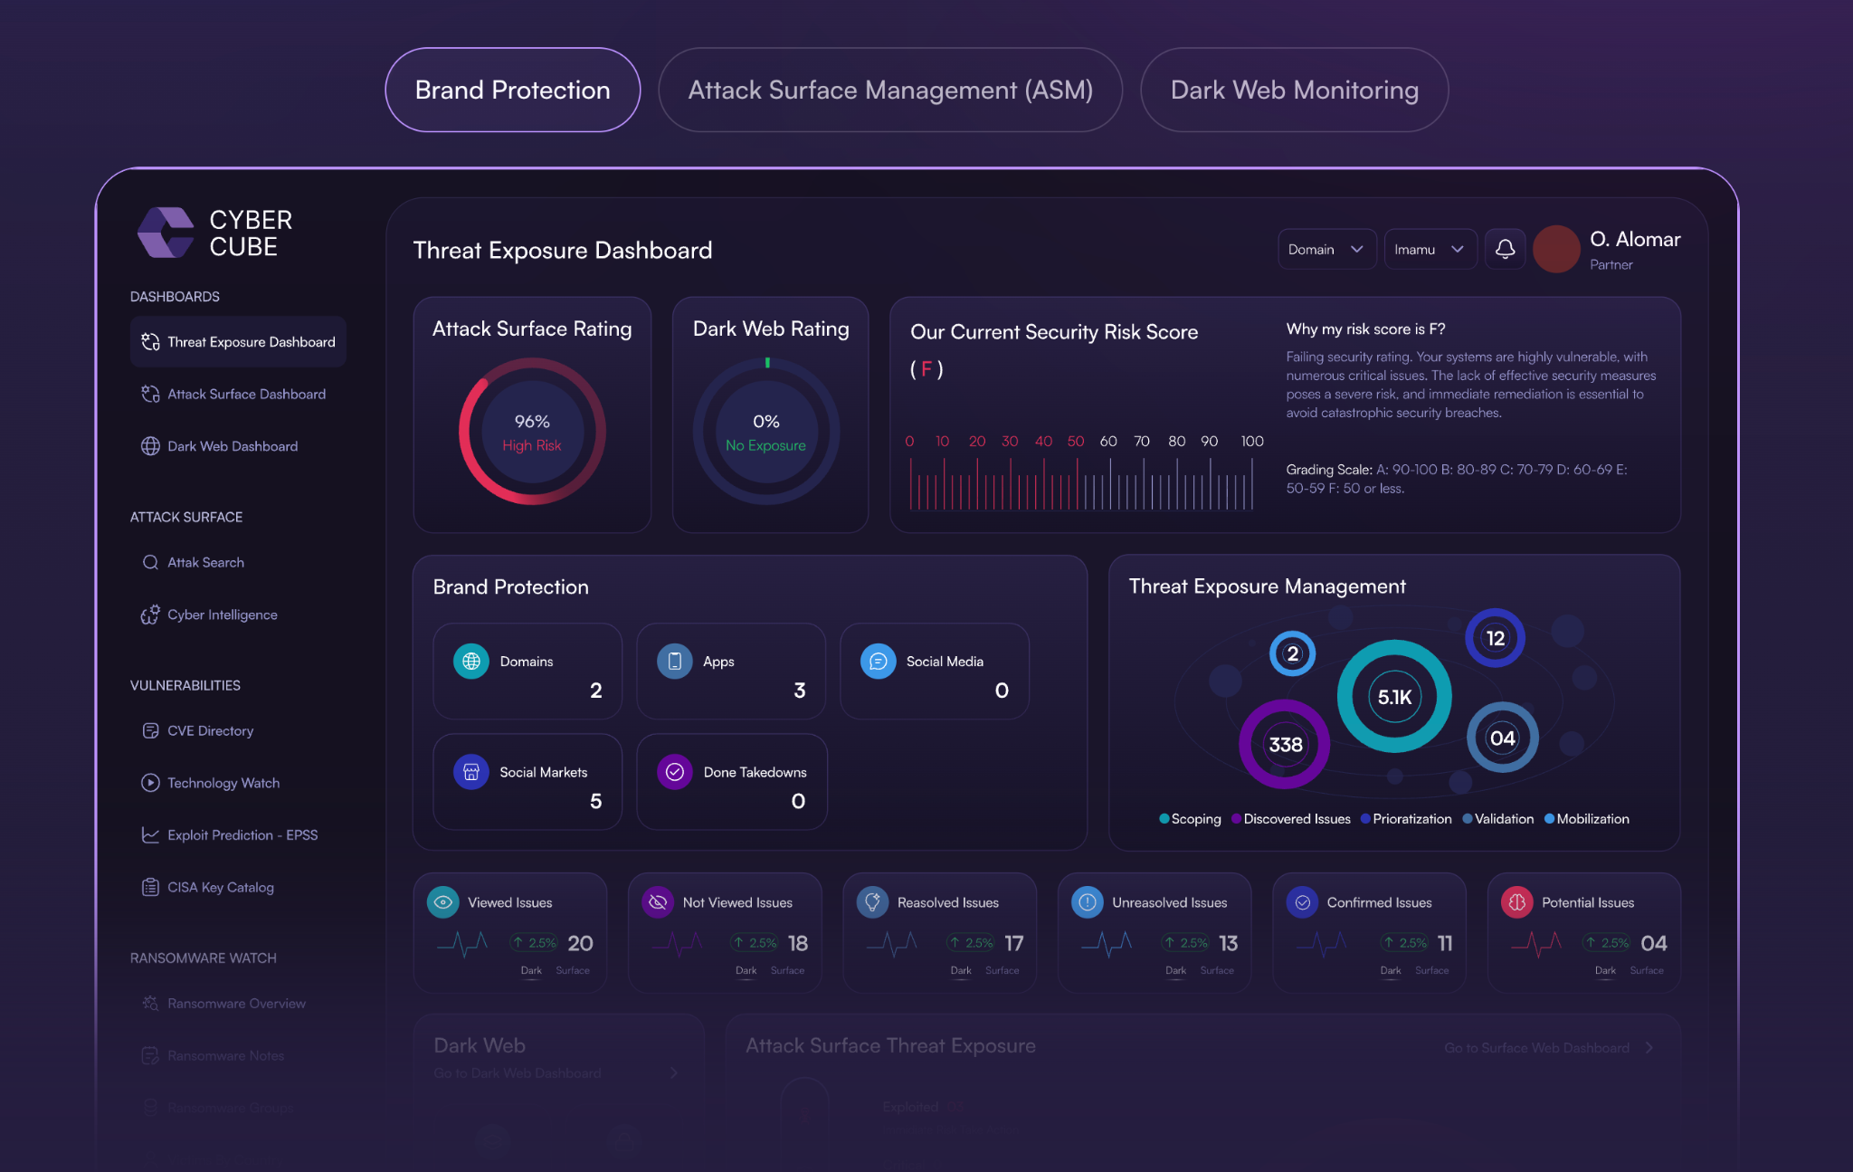

After Solution Section, Put Under the hood section

Delete Platform section + Who is for + Comparison + results + Security and compliance + Get started

